Institute of computer technology

B.Tech-CSE(BDA)

Name:- Shaikh Anik

Sem:-3

Enrollment no.:-23162121021

Batch:-31

Sub:-DBMS

Date:-12/8/24

Practical 3

Q:- Queries on computation on table data:

1) Find the name of all clients having ‘a ‘ as the second letter in their names

2) Find out the clients whose name is four character ling and second letter is ‘a‘.

3) Find out the name of city whose second last character is ‘a’.

4) Print the list of clients whose bal_due is greater than or equal to 10000.

5) Print the information from sales_order table for orders placed in the month of January.

6) Display the order information for client_no ‘C003’ and ‘C001’.

7) Find products whose selling price is greater than 2000 and less than or equal to 5000.

8) Find products whose selling price is more than 1500. Calculate a new selling price as, original

selling price * .15. Rename the new column in the above query as new_price.

9) List the names, city and state of clients who are not in the state of ‘Maharashtra’.

10) Count the total number of orders.

11) Calculate the average price of all products.

12) Determine the maximum and minimum product prices. Rename the output as max_price and

min_price respectively.

13) Count the number of products having price greater than or equal to 1500.

14) Find all the products whose qty_on_hand is less than reorder level.

15) Create table cmaster from client_master table.

16) Insert data in cmaster from client_master where city=’bombay’

17) Create table sales from sales_order with order_no and client_no columns.

18) Insert data in sales from sales_order table.

A=> Query:-

use BDA_23162121020;

create table Sales_order(Order_no varchar(6) ,Order_Date date ,Client_no varchar(6) ,S_no varchar(6) ,Dely_type char(1) ,Billed_yn char(1) ,Dely_Date date ,Order_Status varchar(10));

insert into Sales_order values('O1901' ,str_to_date('02/06/2015', '%d/%m/%Y') ,'C001' ,'S001' ,'F' ,'N' ,str_to_date('20/06/2015', '%d/%m/%Y') ,'InProcess');

insert into Sales_order values('O1902' ,str_to_date('25/01/2015', '%d/%m/%Y') ,'C002' ,'S002' ,'P' ,'N' ,str_to_date('27/06/2015', '%d/%m/%Y') ,'Cancelled');

insert into Sales_order values('O4665' ,str_to_date('18/02/2015', '%d/%m/%Y') ,'C003' ,'S003' ,'F' ,'Y' ,str_to_date('20/02/2015', '%d/%m/%Y') ,'Fullfilled');

insert into Sales_order values('O1903' ,str_to_date('03/04/2015', '%d/%m/%Y') ,'C001' ,'S001' ,'F' ,'Y' ,str_to_date('07/04/2015', '%d/%m/%Y') ,'Fullfilled');

insert into Sales_order values('O4666' ,str_to_date('20/05/2015', '%d/%m/%Y') ,'C004' ,'S002' ,'P' ,'N' ,str_to_date('22/05/2015', '%d/%m/%Y') ,'Cancelled');

insert into Sales_order values('O1908' ,str_to_date('24/05/2015', '%d/%m/%Y') ,'C005' ,'S003' ,'F' ,'N' ,str_to_date('26/05/2015', '%d/%m/%Y') ,'InProcess');

1) select * from client_master where Name like '_a%';

2) select * from client_master where Name like '_a__';

3) select * from client_master where City like '%a_';

4) select * from client_master where Bal_due >= 10000;

5) select * from sales_order where month(order_date) = 1;

6) select * from client_master where Client_no = 'C003'or Client_no = 'C001';

7) select * from product_master where sell_price between 2000 and 5000;

8) select sell_price = 1500 and sell_price * 0.15 new_price from product_master;

9) select * from client_master where state not in('Maharastra');

10) select count(order_no) from sales_order;

11) select avg(sell_price) "Average of Sell Price is:" from product_master;

12) select max(sell_price) "The Maximum Price is:" , min(sell_price) "The Minimum Price is:" from product_master;

13) select count(product_no) "The Total No. Of Product is:" from product_master where sell_price >=1050;

14) select count(product_no) "The Total No. Of Product is:" from product_master where Reorder_lvl > Qty_on_Hand;

15) create table cmaster like client_master;

16) insert into cmaster select * from client_master where city = 'Bombay';

17) create table sales as select order_no , client_no from sales_order;

18) insert into sales (order_no, client_no) select Order_no, Client_no from sales_order;

Screenshot:-

1

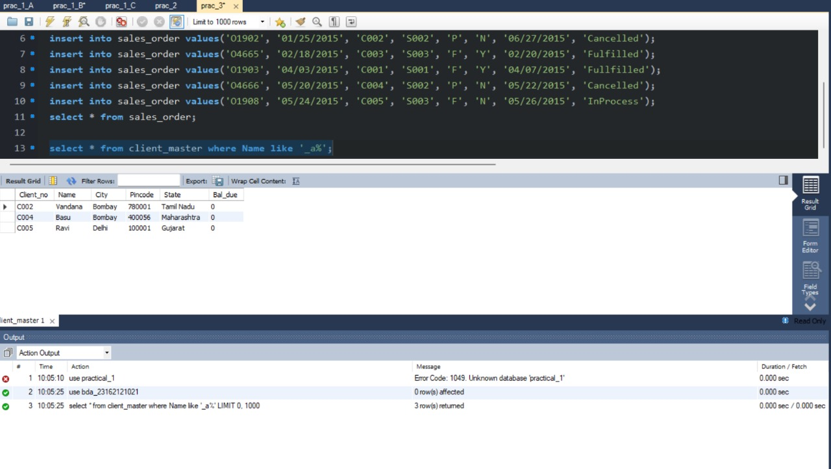

2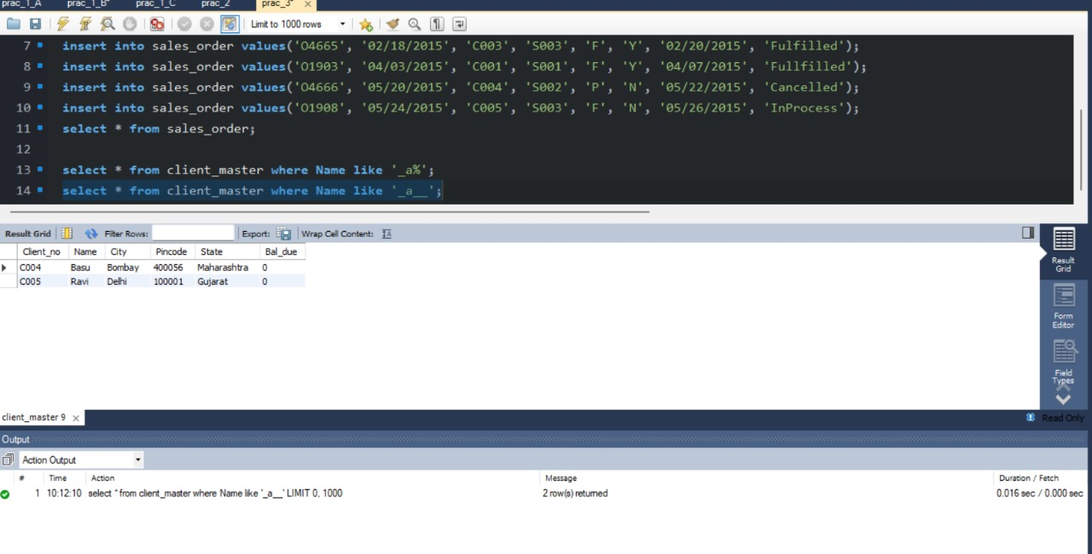

3 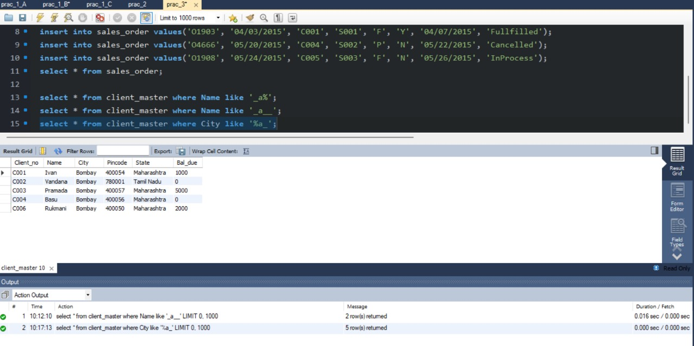

4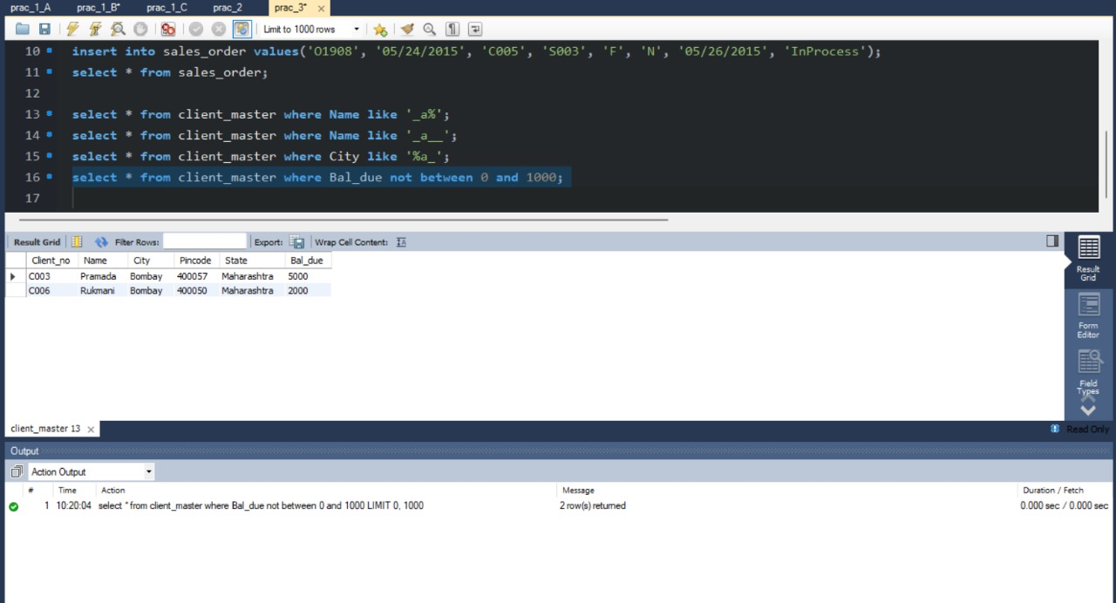

5 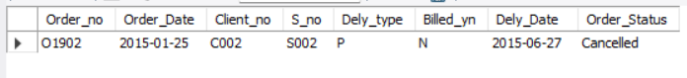

6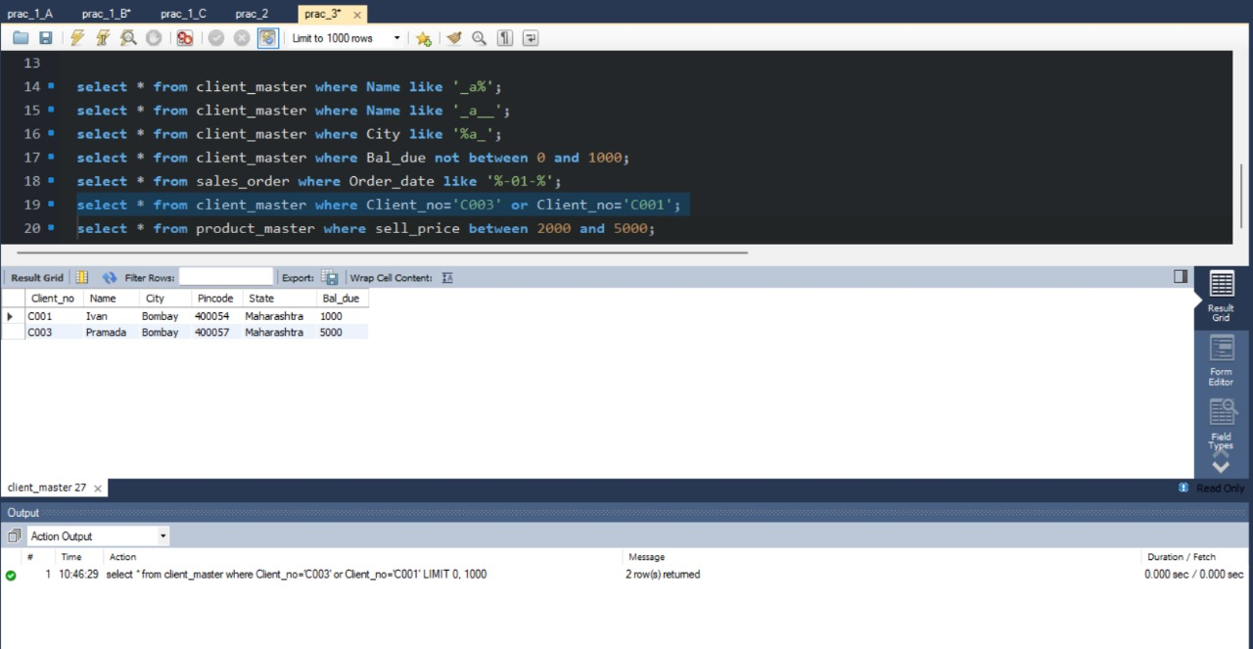

7 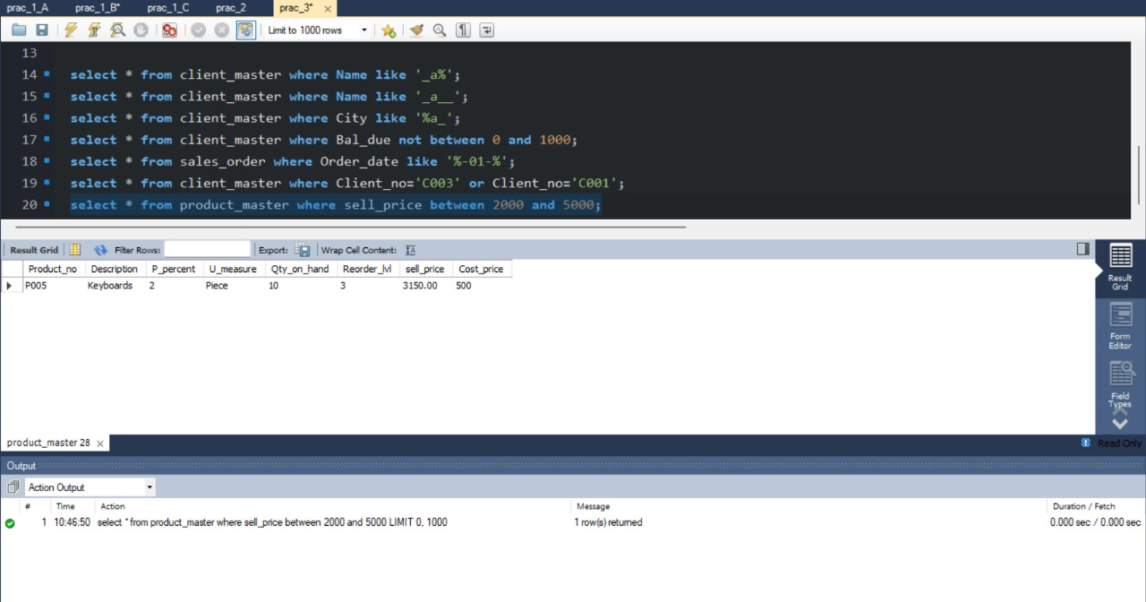

8 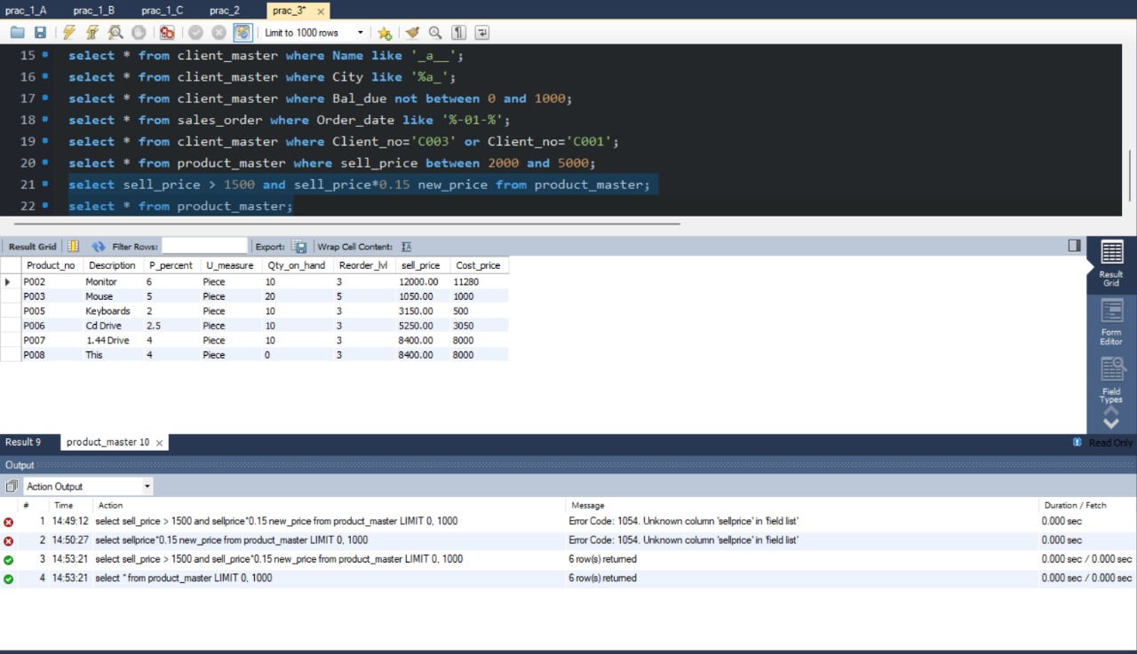

9 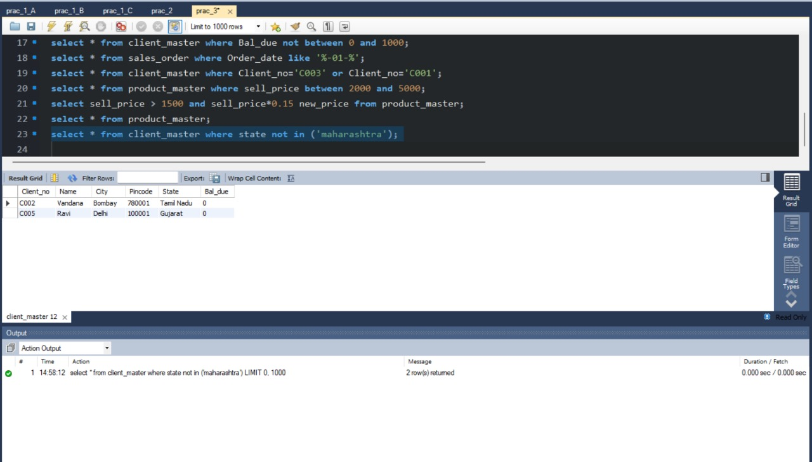

10 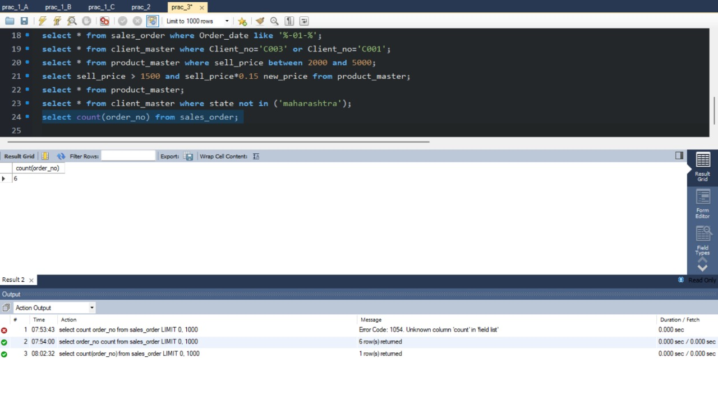

11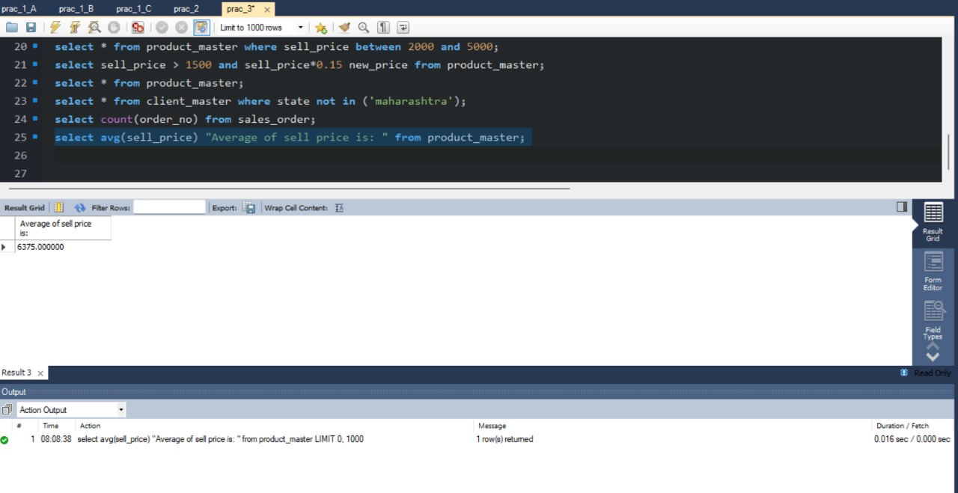

12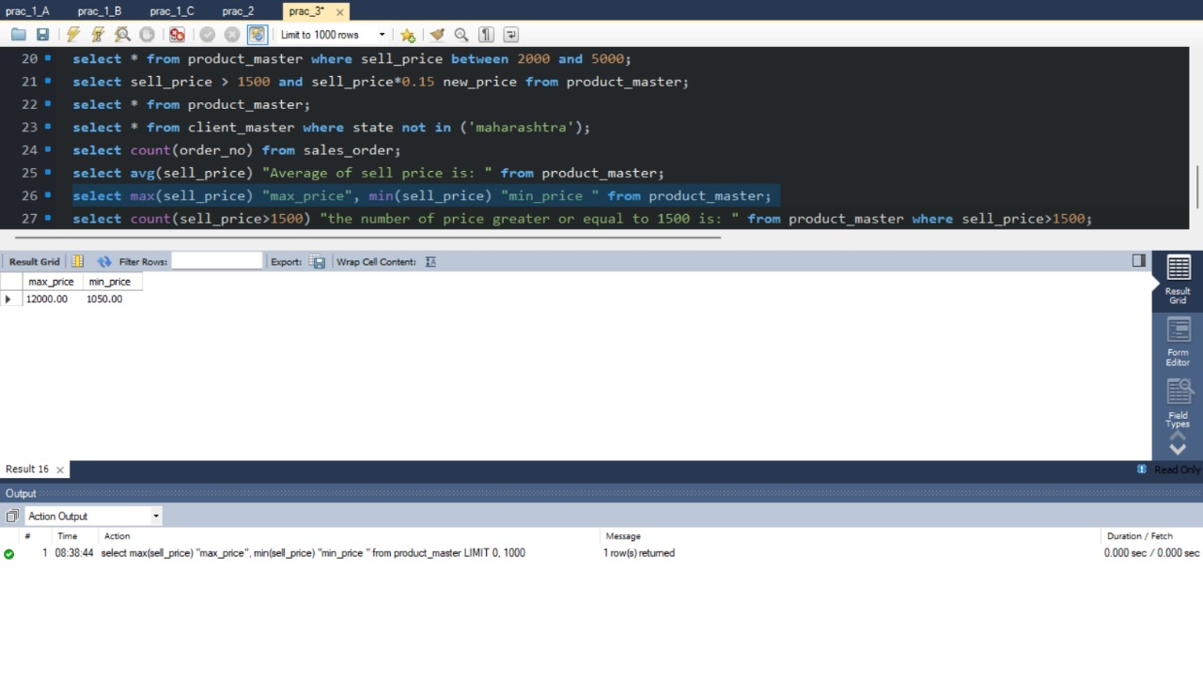

13 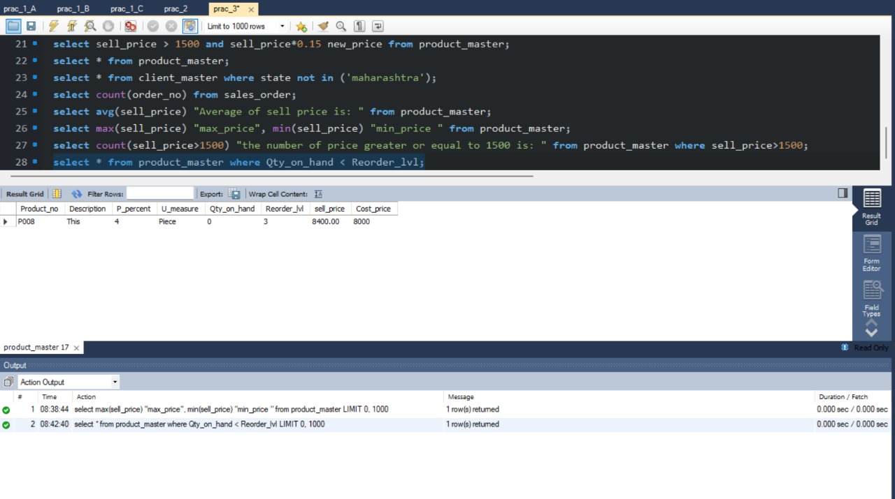

14

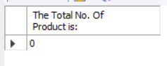

15

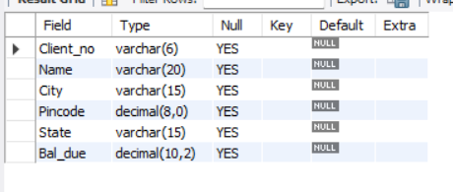

16

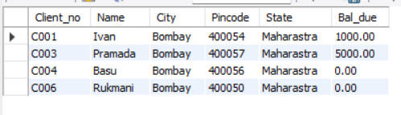

17

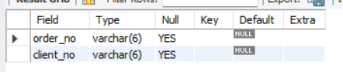

18

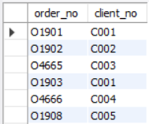

Q:- Queries on Date manipulation:

1) Display the order number and day on which clients placed their order.

2) Display the month (in alphabets) and date when the order must be delivered.

3) Find the number of days elapsed between delivery date and order date from sales_order table.

4) Find the date, 15 days after today’s date.

5) Display current date and time.

6) Display system time..

A=> Query:-

1) select order_no, dayname(order_date) as order_day from sales_order;

2) select date_format(dely_date, '%M %d') as dely_month_date from sales_order;

3) select datediff(dely_date, order_date) as days_elapsed from sales_order;

4) select date_add(current_date(), interval 15 day) as date_after_15_days;

5) select now() as current_date_time;

6) select curtime() as system_time;

Screenshot:-

1

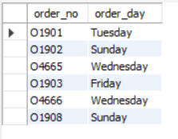

2

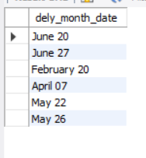

3

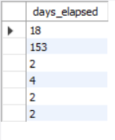

4

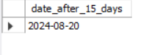

5

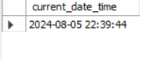

6

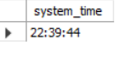

Action logs:- 